Ssh kick us out.

SCP did not work either

Why not sftp.

found out those files

found out rc file

I downloaded with

get rc kali@kali:~

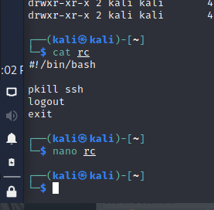

pkill and then a logout, that’s insane

I added sleep 6000 to the rc file.

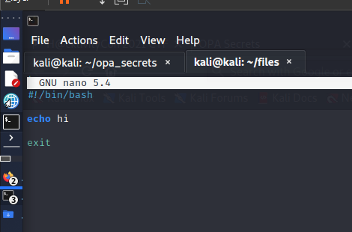

save it and then went back to the SFTP session.

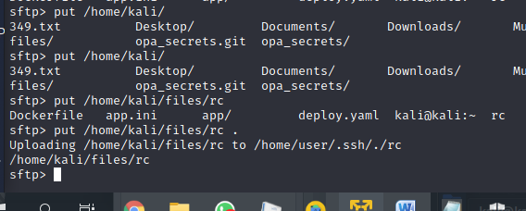

I uploaded the new rc file inside the old rc file.

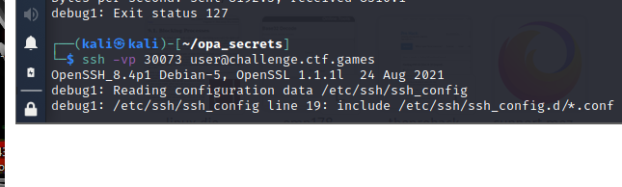

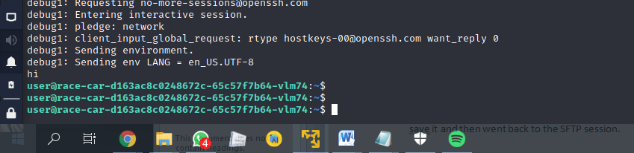

finally!

what about checking privileges

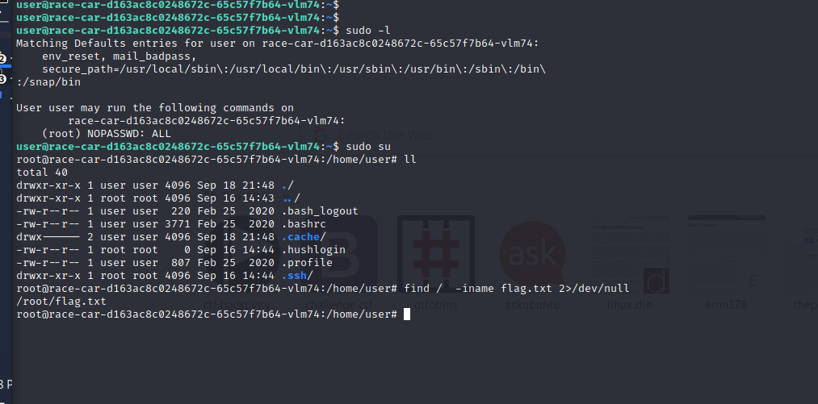

Awesome, as you may see just using sudo and find I found the flag.

thanks!